Project Planning Phase
Project Planning Template (Product Backlog, Sprint Planning, Stories, Storypoints)

Date | 14 October 2026
Team ID
Project Name
Maximum Marks | 5 Marks

Product Backlog, Sprint Schedule, and Estimation (4 Marks)
Use the below template to create product backlog and sprint schedule
Sprint | Functional Requirement (Epic) | User Story Number | User Story / Task | Story Points | Priority | Team Members
Sprint-1 | Data Collection | USN-1 | As a user, I can gather the data from the required sources. | 2 | High
Sprint-1 |  | USN-2 | As a user, I can load the gathered data into the tool. | 1 | High
Sprint-1 | Data Preparation | USN-3 | As a user, I can handle missing values in the data. | 3 | High
Sprint-1 |  | USN-4 | As a user, I can create new fields from the existing data. | 3 | Medium
Sprint-1 |  | USN-5 | As a user, I can handle inconsistency in the data. | 3 | Medium
Sprint-2 | Data Visualization | USN-6 | As a user, I can view the data as a bar chart. | 2 | Medium
Sprint-2 |  | USN-7 | As a user, I can view the data as a pie chart. | 2 | Medium
Sprint-2 |  | USN-8 | As a user, I can view the data as a line chart. | 2 | Low
Sprint-2 |  | USN-9 | As a user, I can view the data on a map. | 4 | Low
Sprint-2 | Dashboard | USN-10 | As a user, I can view all the charts together on a dashboard. | 5 | High
Sprint-2 | Story | USN-11 | As a user, I can view the dashboard views as a story that presents the findings. | 5 | Medium

Project Tracker, Velocity & Burndown Chart: (4 Marks)
Sprint | Total Story Points | Duration | Sprint Start Date | Sprint End Date (Planned) | Story Points Completed (as on Planned End Date) | Sprint Release Date (Actual)
Sprint-1 | 12 | 7 Days | 01 Oct 2026 | 07 Oct 2026
Sprint-2 | 20 | 7 Days | 08 Oct 2026 | 14 Oct 2026

Velocity:
Imagine we have a 10-day sprint duration, and the velocity of the team is 20 (points per sprint). Let’s calculate the team’s average velocity (AV) per iteration unit (story points per day)

Velocity = Total Story Points / Number of Sprints = (12 + 20) / 2 = 16 story points per sprint.
For our project: each sprint is 7 days, so the average velocity per day = 16 / 7 ≈ 2.29 story points per day.

Burndown Chart:
A burn down chart is a graphical representation of work left to do versus time. It is often used in agile software development methodologies such as Scrum. However, burn down charts can be applied to any project containing measurable progress over time.

https://www.visual-paradigm.com/scrum/scrum-burndown-chart/
https://www.atlassian.com/agile/tutorials/burndown-charts
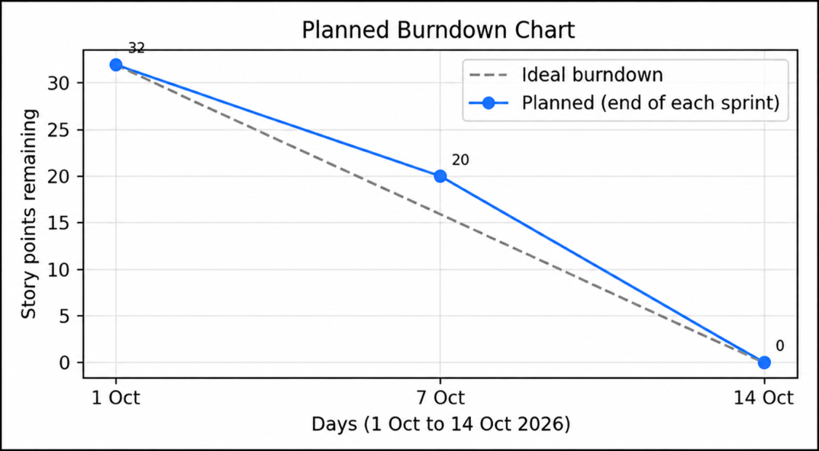

Reference:
https://www.atlassian.com/agile/project-management
https://www.atlassian.com/agile/tutorials/how-to-do-scrum-with-jira-software
https://www.atlassian.com/agile/tutorials/epics
https://www.atlassian.com/agile/tutorials/sprints
https://www.atlassian.com/agile/project-management/estimation
https://www.atlassian.com/agile/tutorials/burndown-charts

